Cornerstone Bible Church
Equipping Hour Bible Study
The Epistle of James
Suggested Commentaries

 |  | Description: The Tyndale New Testament Commentary Series is a conservative scholarly and readable treatment of the scriptures. This volume on James by Douglas Moo begins with an introductory section which discusses the authorship, date, circumstances and message of the letter. The analysis of the text is based on in-depth linguistic and historic research but is readable. A good commentary for the pastor and informed lay person.  CBC Equipping Hour: (3.0 out of 5)  RSV format. Verse by verse.  Some technical notes.  This is Dr. Moo’s first exegetical offering on the Epistle of James. It is fairly complete, and quite concise. A good quick reference. Decent value for the price.  Audience: pastors, bible students, lay persons.
  James, Tyndale New Testament Commentary
  By: Douglas J. Moo
   | Retail Price: $14.00  CBD Price: $10.99  Amazon: $11.49
    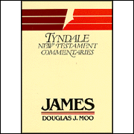
  Type: Trade Paperback
  Number of Pages: 191
  Vendor: Eerdmans Publishing Co.
  Publication Date: 1985
  ISBN: 0802800793
  UPC: 9780802800794
  Dimensions: 5 X 7 1/2
 |  | Description: This highly original commentary seeks to make the Letter of James clear and applicable to Christian living today. Interacting with the latest views on James but keeping academic references to a minimum, Douglas Moo first introduces the Letter of James in its historical context and then provides verse-by-verse comments that explain the message of James both to its first readers and to today's church.  CBC Equipping Hour: (4.5 out of 5)  NIV format. Verse by verse.  Not overly technical.  All usage of Greek has been transliterated.  PNTC commissioned Dr. Moo to rewrite his commentary on James 15 years later, allotting him twice as much space. The result is a more complete and coherent work without major ideological shifts from his original TNTC commentary.  Audience: pastors, bible students, motivated lay persons.
  The Letter of James, Pillar New Testament Commentary
  By: Douglas J. Moo
   | Retail Price: $36.00  CBD Price: $21.99  Amazon: $21.95
    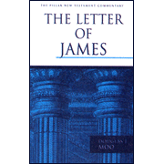
  Type: Hardcover
  Number of Pages: 288
  Vendor: Eerdmans Publishing Co.
  Publication Date: 2000
  ISBN: 0802837301
  UPC: 9780802837301
  Dimensions: 9 X 6
 |  | Description: "Do not merely listen to the Word and so deceive yourselves. Do what it says,"---James 1:22. Packed with practical advice, the Book of James challenges believers to bring their faith "down to earth" by putting Jesus' teachings into action. Whether you're a pastor or layperson, you won't want to miss John MacArthur's illuminating study of this fascinating epistle!  CBC Equipping Hour: (4.0 out of 5)  NASB format. Mostly verse by verse.  Not very technical.  All usage of Greek has been transliterated.  Based on sermons. Excellently devotional and very readable.  Dr. MacArthur doesn’t often discuss contrasting views, but he is excellent at expounding and getting to the heart of Scripture, thus providing a good balance to more academic commentaries.  Audience: congregation, lay persons.
  James, MacArthur New Testament Commentary
  By: John MacArthur
   | Retail Price: $21.99  CBD Price: $16.99  Amazon: $17.81
    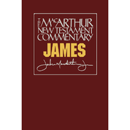
  Type: Hardcover
  Number of Pages: 286
  Vendor: Moody Publishers
  Publication Date: 1998
  ISBN: 0802409008
  UPC: N
  Dimensions: 9 X 6
 |  | Description: In this thorough exegesis of his own working translation, Adamson combats some prevalent notions and corrects misunderstandings of the nature of this unique epistle, which, he says, cannot really be understood apart from the whole context of the New Testament. James B. Adamson studied at the University of Edinburgh and in 1954 was awarded the PH. D. degree from Cambridge University for his thesis on the Epistles of James.  CBC Equipping Hour: (2.5 out of 5)  NIV format. Original translation. Verse by verse.  Very technical.  Though Dr. Adamson provides a scholarly discussion of the Epistle, incorporating a vast array of literature and commentaries, he relies very heavily on JH Ropes’ work. The technical matter discussed, coupled with 9 sections of Excursuses interspersed throughout, yield a somewhat convoluted if not disappointingly cursory rendering of the text. Though this work is highly esteemed and referenced by many authors, it was found wanting.  Audience: academic scholars, pastors, seminarians, advanced bible students.
  The Epistle of James, NICNT, New International Commentary on the New Testament
  By: James B. Adamson, 1976
   | Retail Price: $32.00  CBD Price: $23.99  Amazon: $22.40
    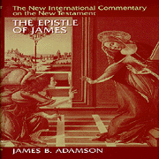
  Type: Hardcover
  Number of Pages: 226
  Vendor: Eerdmans Publishing Co.
  Publication Date: 1994
  ISBN: 080282515X
  UPC: 9780802825155
  Dimensions: 6 1/2 X 9 1/2
 |  | Description: In this NICNT commentary The Letter of James [NICNT] McKnight wants biblical students to read James' powerful letter on its own terms; not Paul's terms; not Luther's terms; not on our terms; James' terms. And those terms are: Ancient Judaism; Torah; the Prophets; the Land; and the centripetal city of Jerusalem; Jesus' teachings.  It is all in this "little" epistle, and with clarity, wit, theological acumen, and exegetical precision, McKnight draws these motifs out masterfully. McKnight, who lands squarely in the "new perspective" on Paul camp encourages us to see this underrated letter anew, to reconsider its themes, its call to holiness, and its call to discipleship--in relationship to faith.  CBC Equipping Hour: (unreviewed)  NIV format. Original translation. Verse by verse.  Adamson’s work was so deficient, that the editors of NICNT re-commissioned the work to McKnight. We assume that it represents an improvement.
  The Epistle of James, NICNT, New International Commentary on the New Testament
  By: Scot McKnight, 2011
   | Retail Price: $55.00  CBD Price: $34.49  Amazon: $37.70
    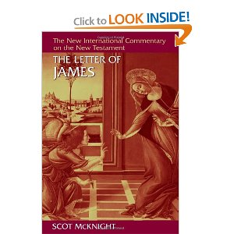
  Type: Hardcover
  Number of Pages: 226
  Vendor: Eerdmans Publishing Co.
  Publication Date: 1994
  ISBN: 080282515X
  UPC: 9780802825155
  Dimensions: 6 1/2 X 9 1/2
 |  | Description: The theological character of the New Testament documents calls for exegesis that is sensitive to theological themes as well as to the details of the historical, linguistic, and textual context. The NIGNT contains detailed verse-by-verse commentary with general comments on each section of the text. Commentary is based upon the UBS Greek New Testament and is not recommended for the reader without a knowledge of NT Greek.  CBC Equipping Hour: (4.5 out of 5)  UBS Greek. Phrase by phrase.  Very technical.  Dr. Davids does a masterful job of combining careful exegesis, scholarly research, and interpretive insight into this excellent commentary. Though his work is very technical, it is balanced, well organized, and quite complete.  Audience: academic scholars, pastors, seminarians, advanced bible students.
  James, New International Greek Testament Commentary
  By: Peter Davids
   | Retail Price: $35.00  CBD Price: $25.49  Amazon: $24.81
    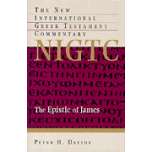
  Type: Hardcover
  Number of Pages: 305
  Vendor: Eerdmans Publishing Co.
  Publication Date: 1982
  ISBN: 0802823882
  UPC: 9780802823885
  Dimensions: 6 1/4 X 9 1/2 X 7/8
 |  | Description: This new volume in the New International Biblical Commentary provides insightful answers for the modern reader confronted by the puzzles of James's thoroughgoing Jewish character. Davids demonstrates how the ''Jewishness'' of the epistle, including its stress on poverty and piety, stems actually from its primitive Christian character. Careful section-by-section exegesis with the NIV as the base text renders James's message accessible and relevant to students of all abilities.  CBC Equipping Hour: (4.0 out of 5)  NIV format. Mostly verse by verse.  Not overly technical. All usage of Greek has been transliterated and appended to the end of each chapter.  Dr. Davids was asked by NIBC to rewrite a “streamlined” version of his NIGTC commentary for a wider audience and for people who do not know Greek. The result is a good work that is very straightforward and simple to the point that it is almost too concise.  Audience: bible students, congregation, lay persons.
  James, New International Biblical Commentary
  By: Peter Davids
   | Retail Price: $11.95  CBD Price: $8.99  Amazon: $9.56
    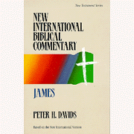
  Type: Trade Paperback
  Number of Pages: 192
  Vendor: Hendrickson Publishers
  Publication Date: 1989
  ISBN: 0943575133
  UPC: 9780853646693
  Dimensions: 5 1/2 X 8 1/2 X 1/2
 |  | Description: Originally published in two separate volumes, Simon Kistemaker's commentaries on James through Jude interpret the NIV text and offer exposition for preachers and Bible students. The author notes recent scholarship and opposing views but stands firmly for biblical inerrancy and authority. This volume offers an extensive introduction and outline, critical notes on the Greek text, comment, and application.  CBC Equipping Hour: (4.5 out of 5)  NIV format. Phrase by phrase.  Not overly technical. Solid work by the chosen successor of William Hendriksen. Very complete, based on the Greek. Well-balanced combination of scholarly discussion and devotional material. After the exposition of each section, Dr. Kistemaker includes very helpful comments on Practical application, Doctrinal implication, and Greek word study. Audience: pastors, bible students, lay persons.
  Exposition of James, Epistles of John, Peter and Jude, New Testament Commentary
  By: Simon Kistemaker & William Hendriksen
   | Retail Price: $49.99  CBD Price: $29.99  Amazon: $30.00
    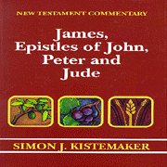
  Type: Hardcover
  Number of Pages: 890
  Vendor: Baker
  Publication Date: 1996
  ISBN: 0801020808
  UPC: 9780801020803
  Dimensions: 9 X 6 X 1 3/4
James, Everyman’s Bible Commentary  By: Vernon Doerksen |  | Description: In a readable, helpful style, Vernon Doerksen explores the practical implications of the great themes of James: working faith, the tongue and a Christian's speech, and the responsibility of Christian teachers.  CBC Equipping Hour: (4.0 out of 5)  NASB format. Mostly verse by verse.  Not very technical. Some Greek word studies.  All usage of Greek has been transliterated.  Dr. Doerksen has written a very straightforward, yet complete commentary on the Epistle of James. Well-balanced amount of scholarly discussion and devotional material. Not the academic tome that other works are, but not an intellectual lightweight either. It is an excellent value and a pleasant surprise (given the size and price).  Audience: bible students, congregation, lay persons.
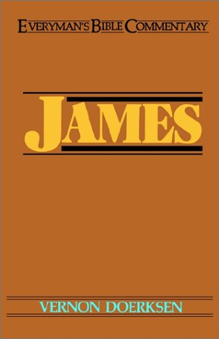 | Retail Price: $7.49  CBD Price: $5.67 (ebook)  Amazon: $9.99 (paperback)  Paperback: 148 pages; Dimensions (in inches): 0.42 x 7.48 x 5.15  Publisher: Moody Publishers; (July 2001)  ISBN: 0802402429
 |  | Description: Dr. Hiebert uses his knowledge of Greek to practical effect for pastors and Bible students. His expositional approach is well-suited for personal or public study. The author writes in a way that reflects James' practicality. He provides a bibliography for further reading.  CBC Equipping Hour: (4.0 out of 5)  ASB format. Mostly phrase by phrase.  (The ASB is the 1901 precursor to the NASB.)  Not overly technical.  All usage of Greek has been transliterated.  This is an excellent work by a very good bible commentator. Dr. Hiebert’s methodic handling of the text, along with a discussion of then-current literature yields a very complete and thorough exegesis of James.  Audience: pastors, bible students, motivated lay persons.
  James
  Author: D. Edmond Hiebert
   | Retail Price: $19.99  CBD Price: $13.99  Amazon: $17.98
    
  Paperback: 348 pages
  Publisher: BMH Books (January 1, 2002)
  Language: English
  ISBN-10: 0884692531
  ISBN-13: 978-0884692539
  Product Dimensions: 6.1 x 0.9 x 9 inches

